**ELECTIVE 3: FULLSTACK WEB DEVELOPMENT**

**PRELIMINARY EXAMINATION**

**1st Semester, Academic Year 2019-2020**

Please follow the directions for each section. Note that in each section you will have some amount of choice in the questions you’ll be answering. The exam is based on a 100-point scale. Partial credit will be given for answers that are done partially well.

**Programming** (50 points ).

1. Create a basic website (without JavaScript) that has the following layout below with the ff. Instructions
   1. Should be posted in Github with the format E3PE_LASTNAME_FIRSTNAME for the project name.
   2. Follow layout below:

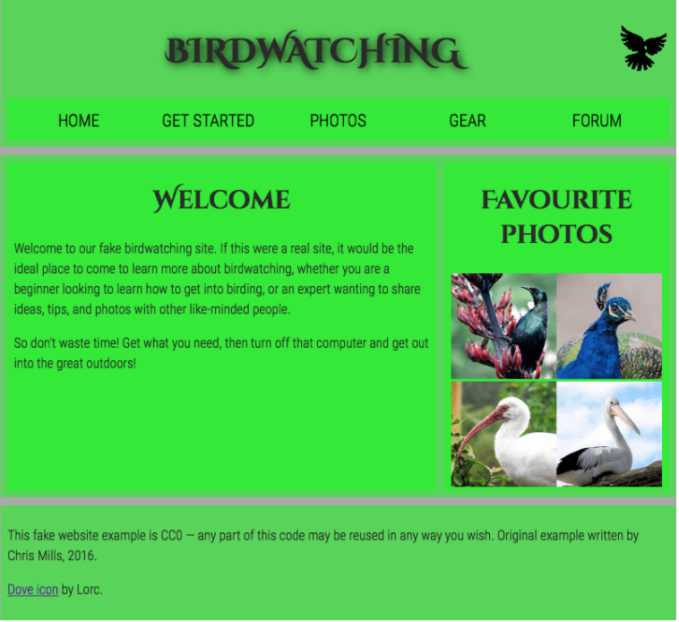

* 1. Logos and pictures can be changed.
  2. Fonts can be altered.

**Essay** (25 points):

1. How would you say that front-end development has evolved over the years? State some key difference from then (like 10 years ago) to now.

The front-end development has widely evolved over the years if we look back to at least year 2000, the only design that there is mostly tables and division for the front end, and the sizing of the image are mostly the same, in rare cases, they aren’t even intended on the proper sizing.

As years goes by, css has been created and that’s most likely one of the revolutionary within the front-end development where the css now has a lot more properties more than possibly before where everything is just black and white with tables and division, now with css, you can now have more design such as padding, margins, colors, positioning, and a lot more.

With recent years, the comparison is again tremendous, with the things like SVG to make things simple but intuitive/responsive, and now there’s a ruling for web design to make it really good like minimalist design, and a lot more different kind of design standards that the developers usually try to follow. Now we also have responsive UIs that really makes the appeal for the front-end, and nowadays, front-end is as important as the back-end now as its now literally half of a whole, without it, the website won’t sell, or its boring in a sense.

1. Provide a code snippet that shows CSS precedence between element selectors, class selectors and inline styling.

**Inline CSS**

<body style="background-color: green;">

</body>

**Internal CSS**

<head>

<style>

body {

background-color: blue;

}

</style>

</head>

**External CSS ID or class**

.className {

color: #333;

}

#idName {

font-size: 15px;

}

**External CSS tag selectors**

body {

background-color: red;

}

h1 {

color: #222;

}

|  |  |  |
| --- | --- | --- |
| Prepared By:  NINO FRANCISCO ALAMO  Professor /Instructor | Reviewed By:  REGIE ELLANA  CCS Dean | Approved By:  DR. LEAH DIGO  VP for Academic Affairs |

|  |
| --- |
| **LOA-OAA-TOS-028** |
| **10-02-2020 | REV. 00** |

|  |  |
| --- | --- |
| **CODE** | **ELEC323** |
| **TITLE** | **ELECTIVE 3: FULLSTACK DEVELOPMENT** |
| **EXAM** | **PRELIMINARY EXAMINATION** |
| **TERM/AY** | **2ND SEMESTER, ACADEMIC YEAR 2019-2020** |

|  |  |  |  |  |  |  |  |  |
| --- | --- | --- | --- | --- | --- | --- | --- | --- |
| **Topic #** | **Objectives** | **Remember** | **Understand** | **Apply** | **Analyze** | **Evaluate** | **Create** | **Total # of Items/points** |
| 1 | * To apply the concepts of MVC   + - * + Creating Views         + Persisting to Database | 2 | 2 | 2 | 1 | 1 | 2 | **10** |
| **Total # of items/Points** | | 2 | 2 | 2 | 1 | 1 | **2** | **10** |

|  |  |  |
| --- | --- | --- |
| Prepared By:  NINO FRANCISCO ALAMO  Professor /Instructor | Reviewed By:  REGIE ELLANA  CCS Dean | Approved By:  DR. LEAH DIGO  VP for Academic Affairs |